Assignment 6

Colossal-AI is a unified parallel training system designed to seamlessly integrate different paradigms of parallelization techniques including data parallelism, pipeline parallelism, multiple tensor parallelism, and sequence parallelism.

Here in this assignment, I will experiment with the use of LR range test, using Colossalai framework. The chosen model and datasets are LeNet5 and MNIST.

For this experiment, I will use 2 optimizers: SGD and Adam.

4 learning rate scheduling methods : LambdaLR, MultiplicativeLR, MultiStepLR, OneCycleLR - cos, OneCycleLR - linear

Number of epochs: 30

Let’s start with SGD optimizer

LAMBDA LR

optimizer = torch.optim.SGD(model.parameters(), lr=0.1, momentum=0.9, weight_decay=5e-4)

lr_scheduler = torch.optim.lr_scheduler.LambdaLR(optimizer, lrs)

Learning Rate vs train Steps

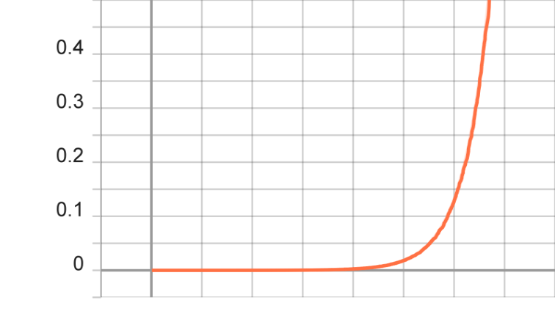

Test loss vs steps
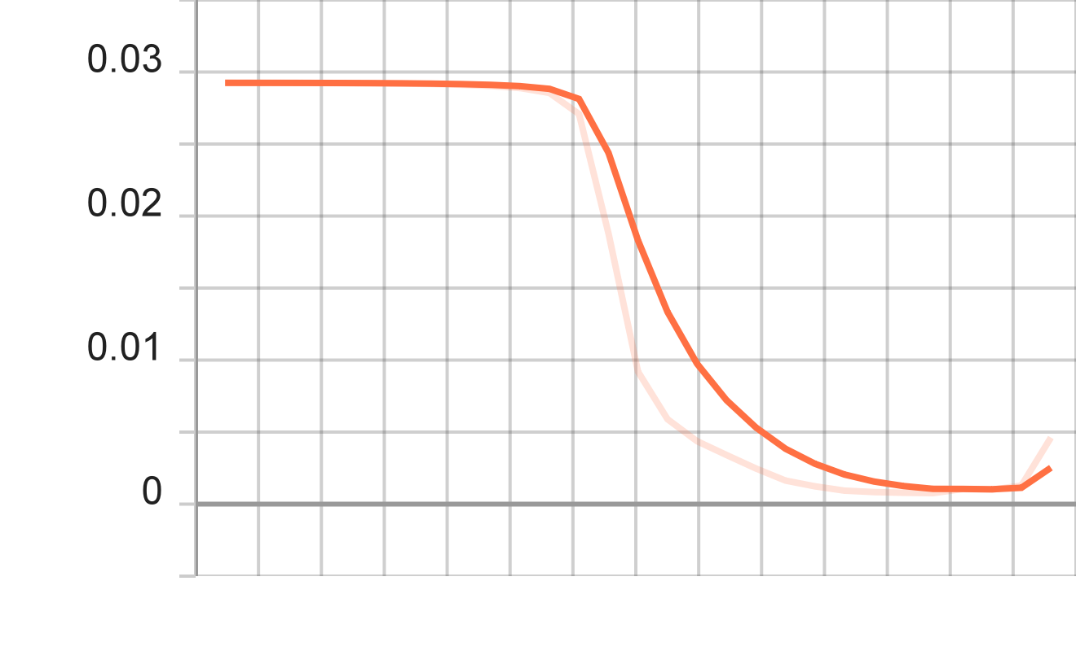

Training Loss vs Step
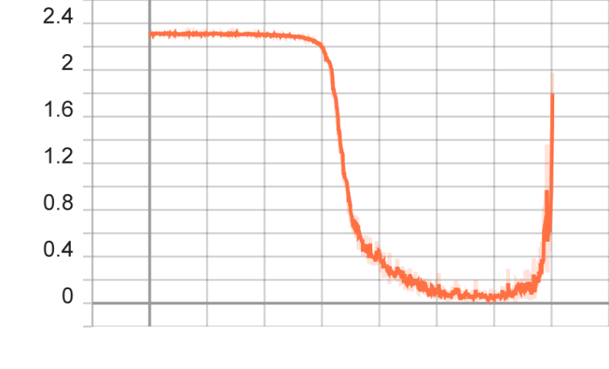

MultiplicativeLR
optimizer = torch.optim.SGD(model.parameters(), lr=0.1, momentum=0.9, weight_decay=5e-4)

scheduler = torch.optim.lr_scheduler.MultiplicativeLR(optimizer, lr_lambda=lmbda)

Learning Rate vs train Steps

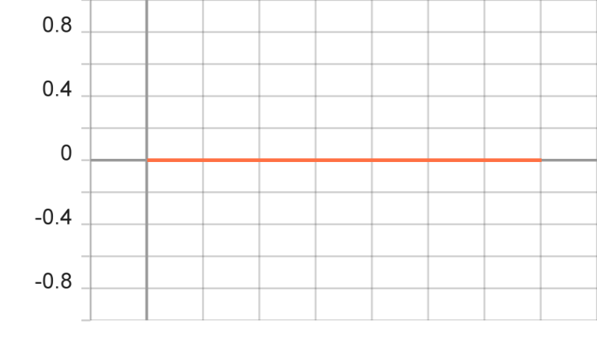

Test loss vs steps

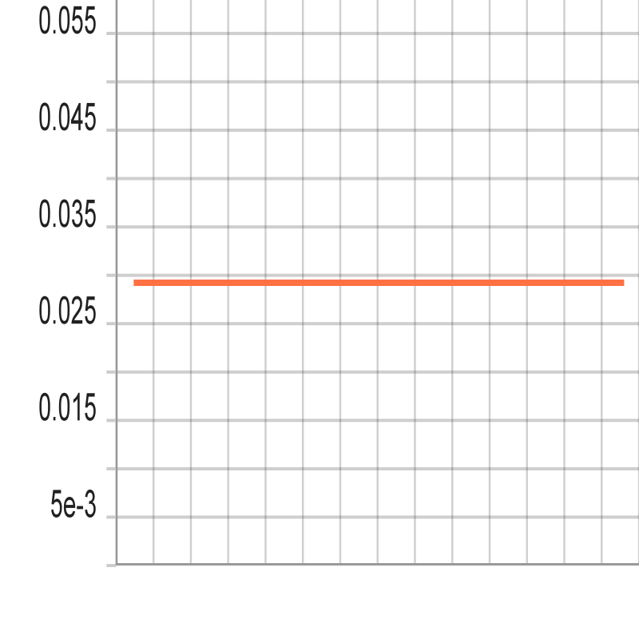
Training Loss vs Step

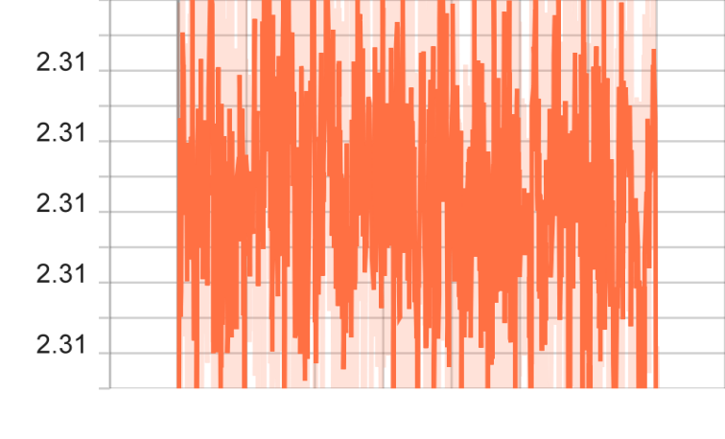

MultiStepLR

scheduler = torch.optim.lr_scheduler.MultiStepLR(optimizer, milestones=[6,8,9], gamma=0.1)

Learning Rate vs train Steps
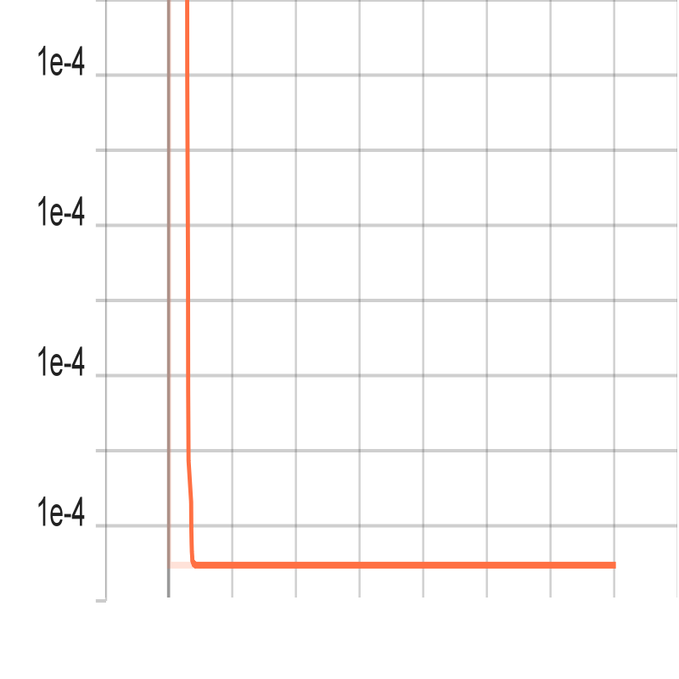

Test loss vs steps

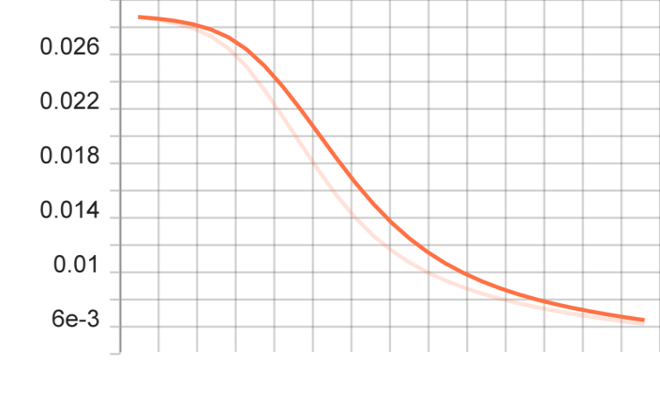
Training Loss vs Step

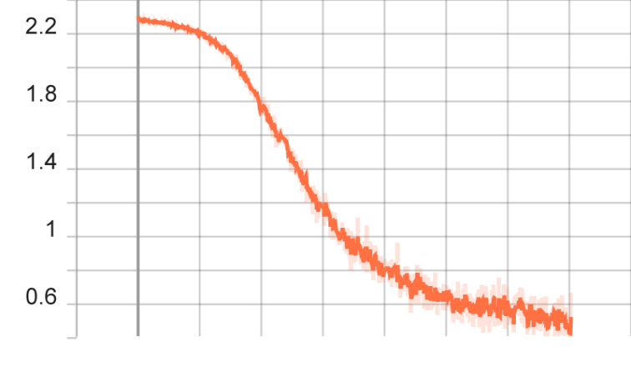

OneCycleLR - cos
Learning Rate vs train Steps
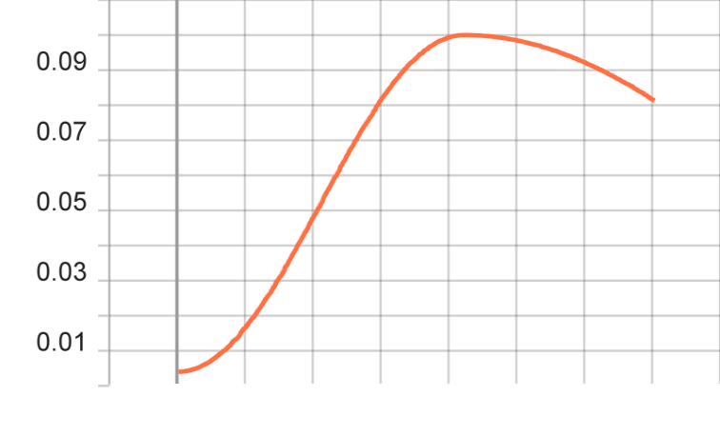
Test loss vs steps

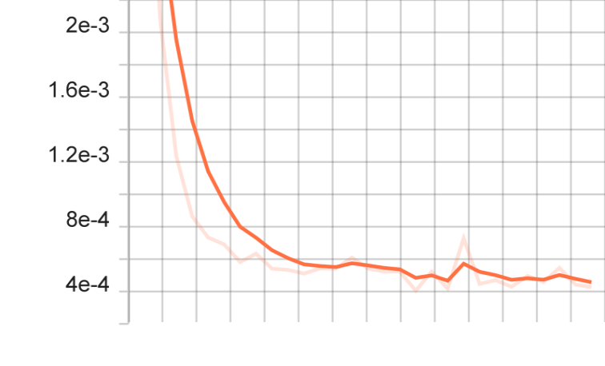
Training Loss vs Step

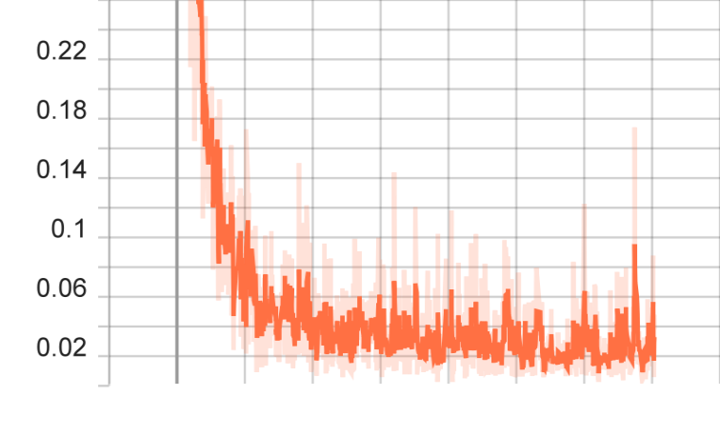

OneCycleLR - linear

Learning Rate vs train Steps
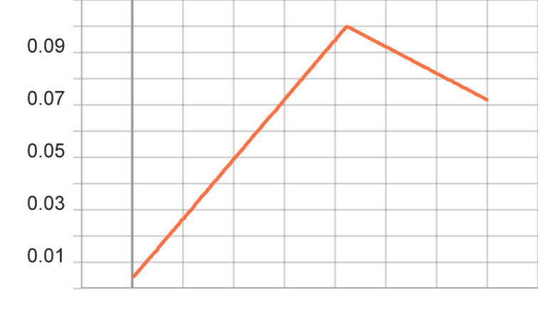
Test loss vs steps

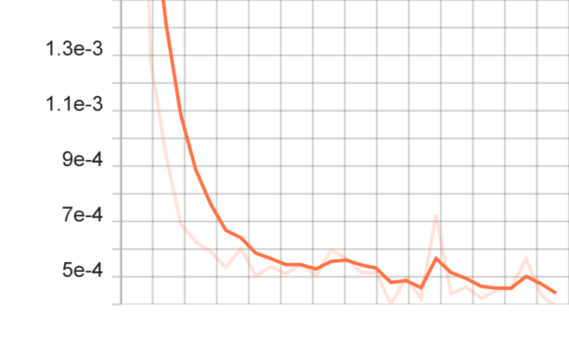
Training Loss vs Step

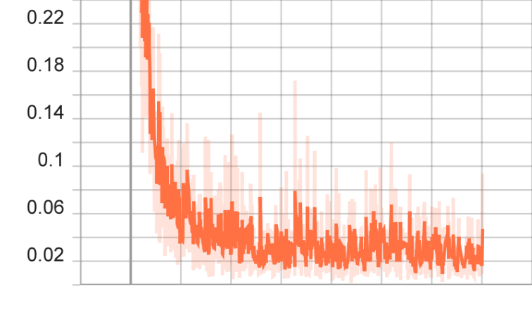

Adam

LAMBDA LR

lr_scheduler = torch.optim.lr_scheduler.LambdaLR(optimizer, lrs)

Learning Rate vs train Steps

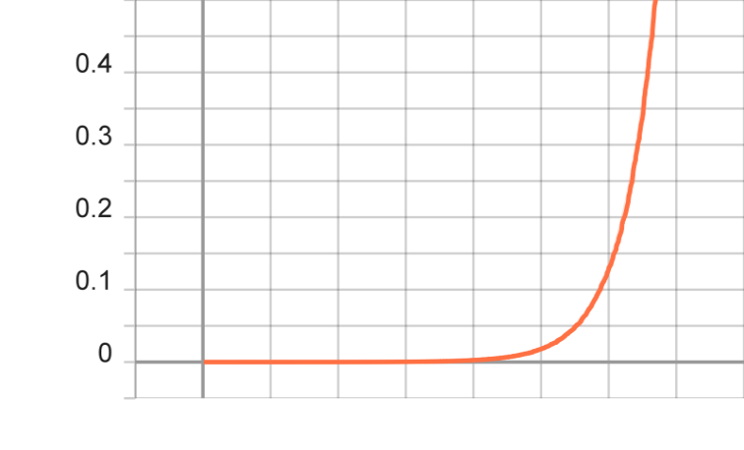
Test loss vs steps

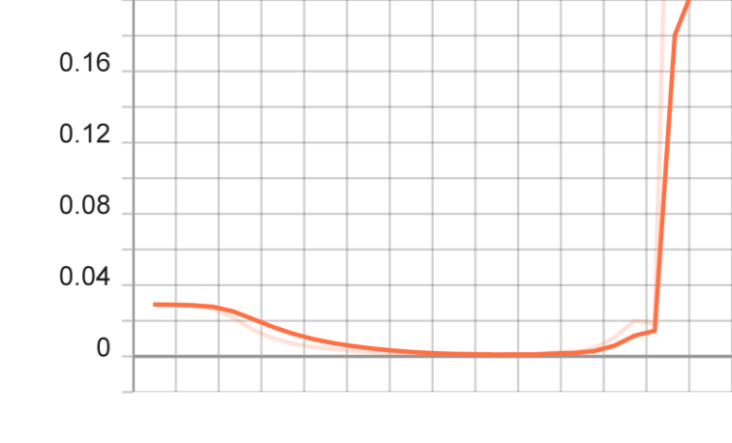
Training Loss vs Step

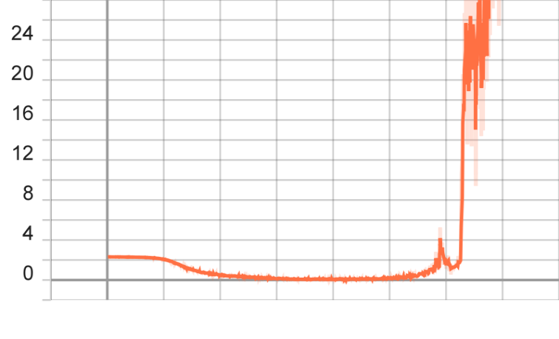

OneCycleLR - linear

lr_scheduler = torch.optim.lr_scheduler.OneCycleLR(optimizer, max_lr=0.1,steps_per_epoch=2*(len(train_dataloader)), epochs=30,anneal_strategy='linear')

Learning Rate vs train Steps

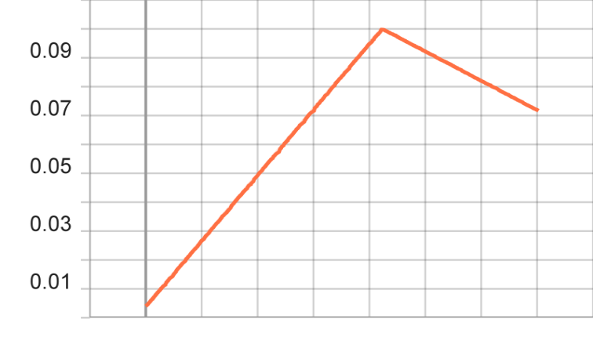

Test loss vs steps

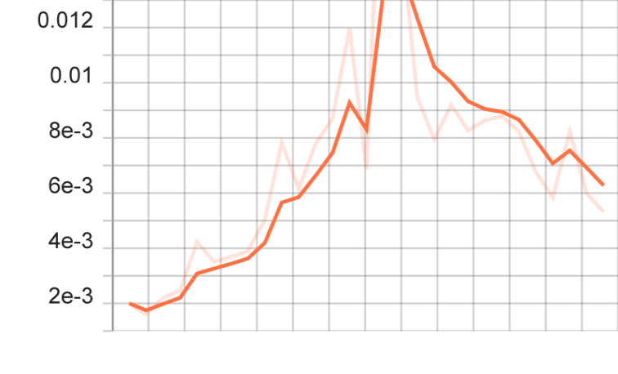
Training Loss vs Step

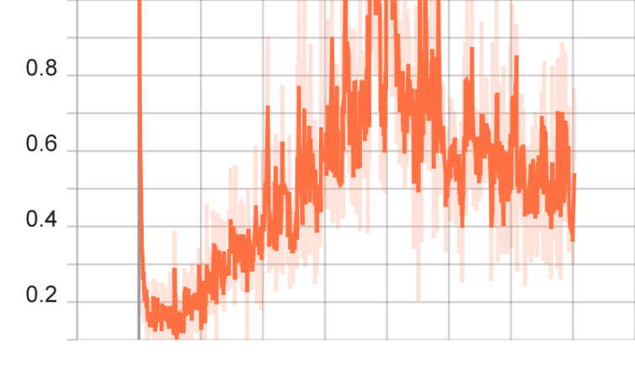

OneCycleLR - cos

lr_scheduler = torch.optim.lr_scheduler.OneCycleLR(optimizer, max_lr=0.1, steps_per_epoch=2*(len(train_dataloader)), epochs=30)

Learning Rate vs train Steps

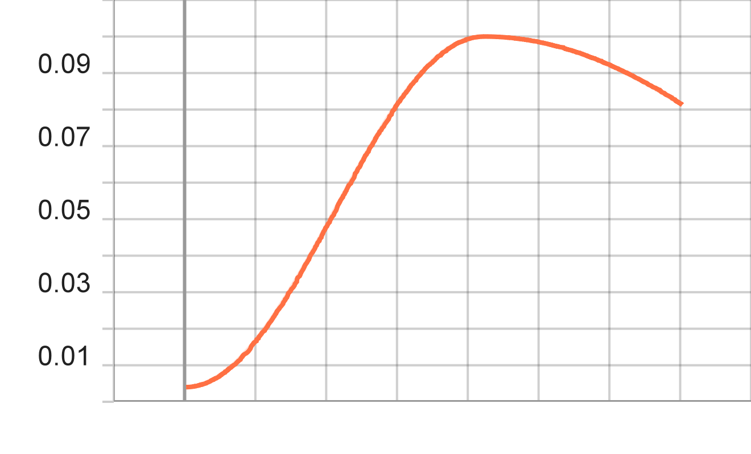

Test loss vs steps

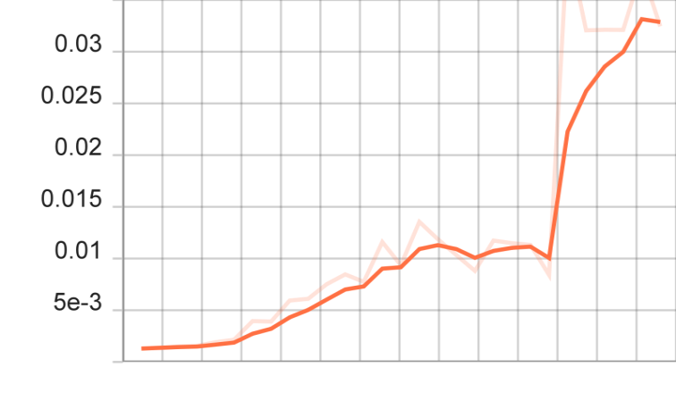

Training Loss vs Step

